LAPORAN PRAKTIKUM – HEAP TREE
Laporan ini disusun untuk memenuhi Tugas ke-11 Praktikum Algoritma & Pemrograman
Dosen Pengampu : Dr. Ionia Veritawati, S.Si., MT.



Oleh :
Nama : Kevin Samuel Fernatyanan
NPM : 4525210033

PROGRAM STUDI TEKNIK INFORMATIKA
FAKULTAS TEKNIK
UNIVERSITAS PANCASILA
2025/2026
Soal Heap Tree_3
Berdasarkan contoh no.1 HEAP TREE, buat pengurutan dengan data inputan secara descending (nama file : PASD11-03.ccp):
- Source Code
#include <iostream>
using namespace std;

void HEAP(int CanArray[], int n, int i){
int temp, canbesar=i, kiri=2*i+1, kanan=2*i+2;
if(kiri < n && CanArray[kiri] < CanArray[canbesar])
canbesar = kiri;
if(kanan < n && CanArray[kanan] < CanArray[canbesar])
canbesar = kanan;
if(canbesar != i){
temp = CanArray[i];
CanArray[i] = CanArray[canbesar];
CanArray[canbesar] = temp;
HEAP(CanArray, n, canbesar);
}
}

void sort(int CanArray[], int n){
int temp;
for (int i = n/2-1; i>=0; i--)
HEAP(CanArray, n, i);
for(int i=n-1; i>=0; i--){
temp = CanArray[0];
CanArray[0] = CanArray[i];
CanArray[i] = temp;
HEAP(CanArray, i, 0);
}
}

int main(){
int n=7, i;
int CanArray[n];
for(i=0;i<n;i++){
cout<<"Masukkan data ke-"<< i <<": "; cin>>CanArray[i];}
cout<<endl;
cout<<"data sebelum diurut :";
for (i=0; i<n; i++)
cout<<CanArray[i]<<" ";
sort(CanArray, n);
cout<<endl;
cout<<"data setelah diurut :";
for (i=0; i<n; ++i)
cout<<CanArray[i]<<" ";
cin.get();
}

- SS Program
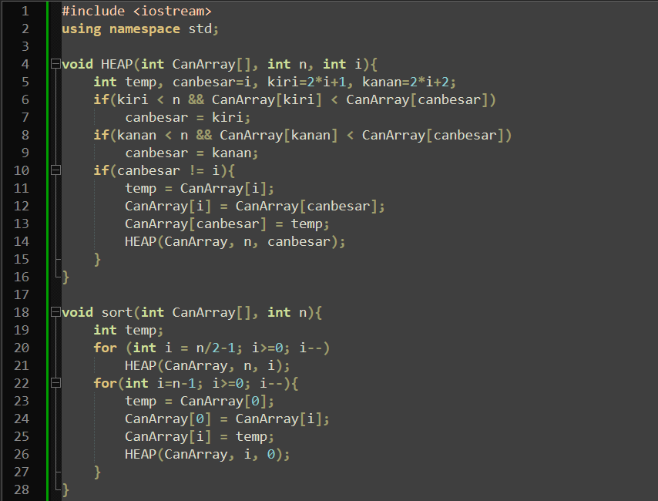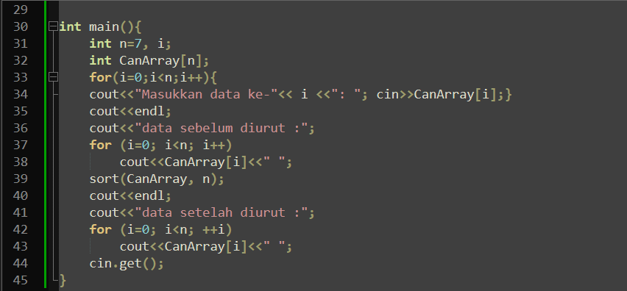

- SS Output
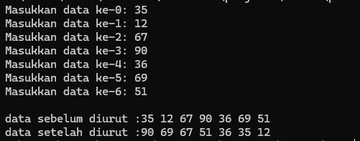

Soal Heap Tree_5
Berdasarkan contoh no.1 HEAP TREE, buat dengan data yang berupa huruf pengurutan secara descending (nama file : PASD11-05.ccp):
- SourceCode
#include <iostream>
using namespace std;

void HEAP(char CanArray[], int n, int i){
int temp, canbesar=i, kiri=2*i+1, kanan=2*i+2;
if(kiri < n && CanArray[kiri] < CanArray[canbesar])
canbesar = kiri;
if(kanan < n && CanArray[kanan] < CanArray[canbesar])
canbesar = kanan;
if(canbesar != i){
temp = CanArray[i];
CanArray[i] = CanArray[canbesar];
CanArray[canbesar] = temp;
HEAP(CanArray, n, canbesar);
}
}

void sort(char CanArray[], int n){
int temp;
for (int i = n/2-1; i>=0; i--)
HEAP(CanArray, n, i);
for(int i=n-1; i>=0; i--){
temp = CanArray[0];
CanArray[0] = CanArray[i];
CanArray[i] = temp;
HEAP(CanArray, i, 0);
}
}

int main(){
int n=7, i;
char CanArray[n];
for(i=0;i<n;i++){
cout<<"Masukkan data ke-"<< i <<": "; cin>>CanArray[i];}
cout<<endl;
cout<<"data sebelum diurut :";
for (i=0; i<n; i++)
cout<<CanArray[i]<<" ";
sort(CanArray, n);
cout<<endl;
cout<<"data setelah diurut :";
for (i=0; i<n; ++i)
cout<<CanArray[i]<<" ";
cin.get();
}

- SS Program
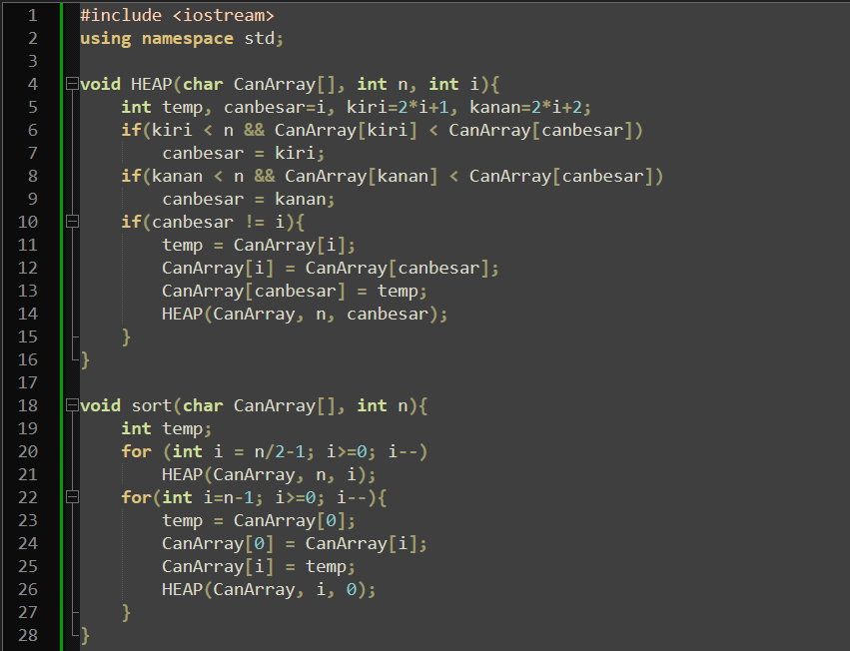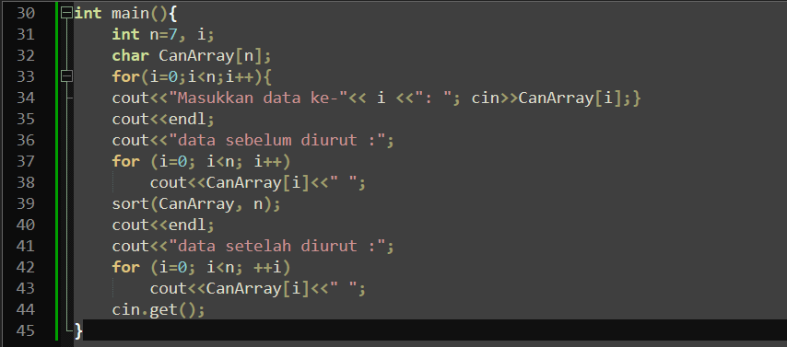

- SS Output
